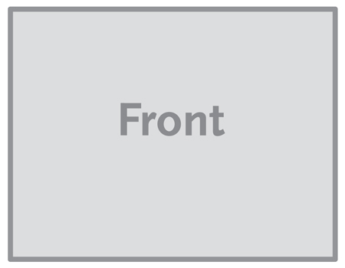

***The image below is a sample image.***

***Insert the images for your brochure like this.***

**Single Sheet / Flyer - 11” x 8.5”**

***This is a sample text box. Place the text for your brochure* in text boxes like this.**