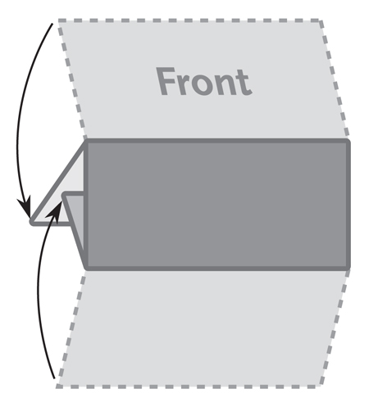

***The image below is a sample image.***

***Insert the images for your brochure like this.***

**3 Panel Letter Fold**

**Brochure**

**8.5” x 3.667”**

***This is a sample text box. Place the text***

***for your brochure in text boxes like this.***