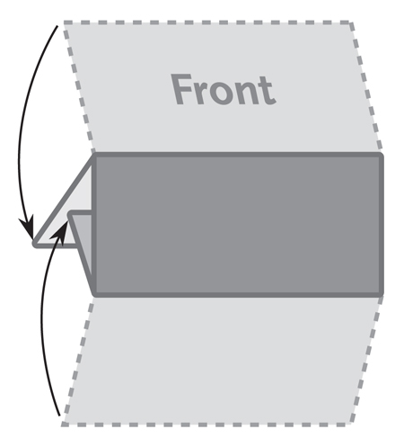

**3 Panel Letter Fold Brochure**

**210mm x 100mm**

***This is a sample text box. Place the text***

***for your brochure in text boxes like this.***

***The image below is a sample image.***

***Insert the images for your brochure like this.***