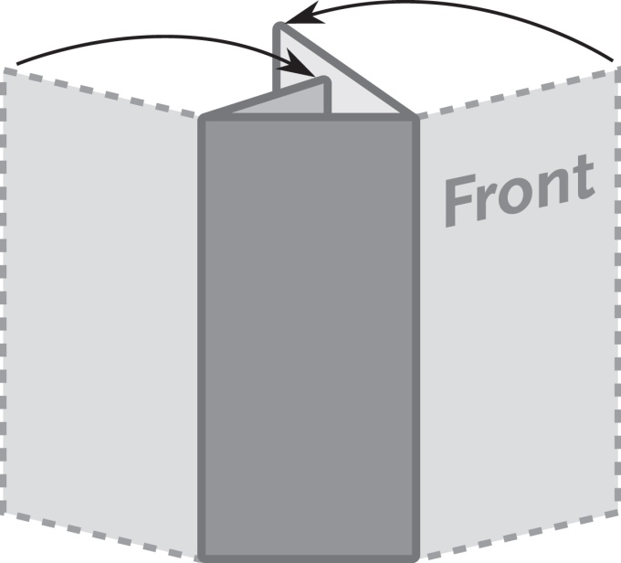

**3 Panel Letter Fold Brochure**

**100mm x 210mm**

***This is a sample text box.***

***Place the text for your brochure in***

***text boxes like this.***

***The image below is a sample image.***

***Insert the images for your brochure like this.***