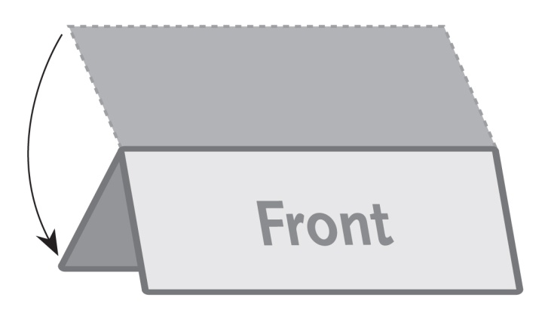

**2 Panel Wide / Table Tent – 11”x4.25”**

***This is a sample text box. Place the text for your brochure in text boxes like this.***

***The image to the right is a sample image.***

***Insert the images for your brochure like this.***